Day46 - Task24 - Jenkins(Part-3)

Task 1: Pipeline Job for VProfile-1 (Git Clone, SonarQube Traditional Install, Slack Alerts)

Step 1: Install SonarQube Server (Traditional / Manual Install)
MySQL Database Server or MyQL RDS instance..
- yum update
- sudo wget https://dev.mysql.com/get/mysql84-community-release-el9-1.noarch.rpmsudo
- sudo dnf install mysql84-community-release-el9-1.noarch.rpm -y
- sudo rpm --import https://repo.mysql.com/RPM-GPG-KEY-mysql-2025
- sudo yum install mysql-community-server
- sudo systemctl start mysqld.service
- mysql --version
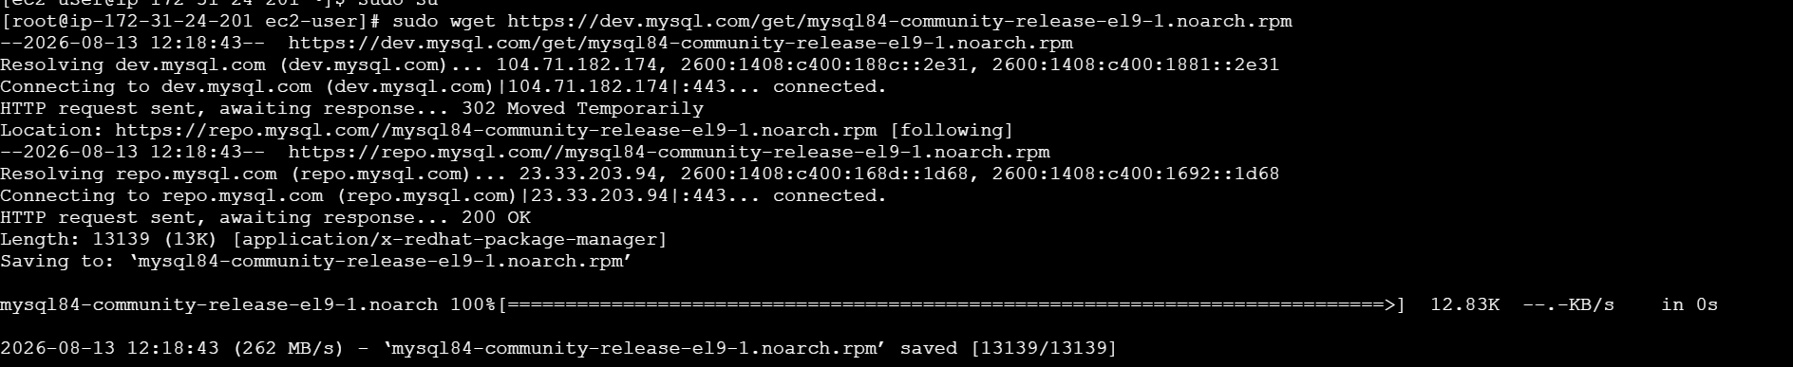
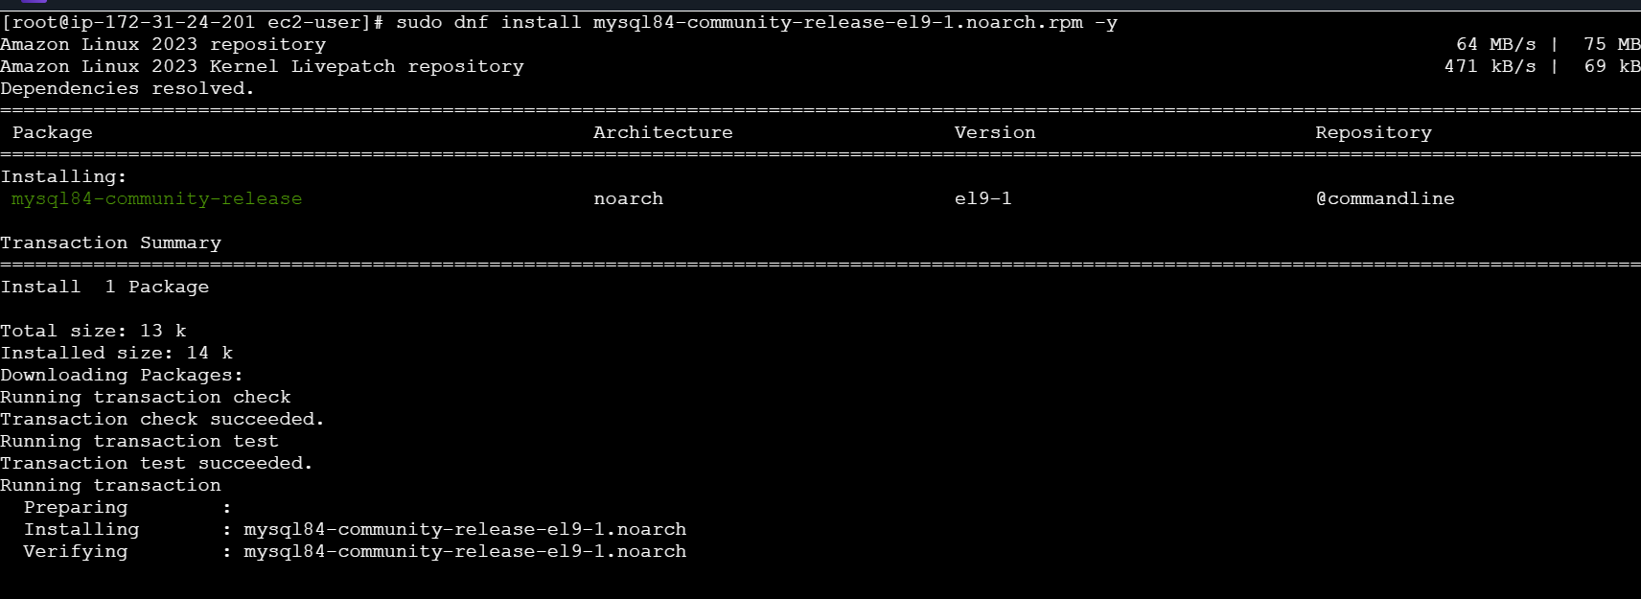
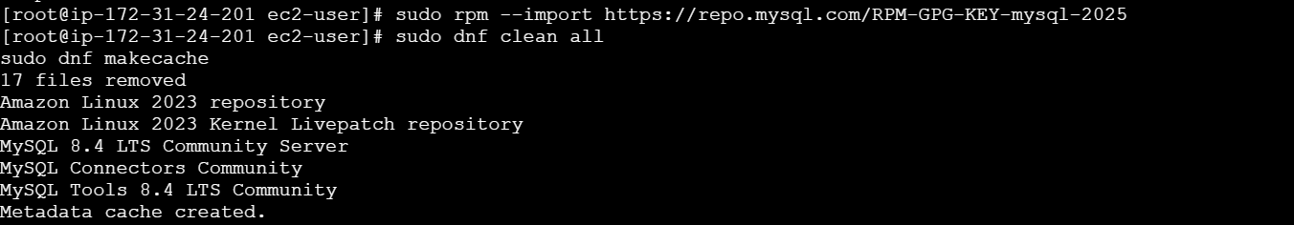
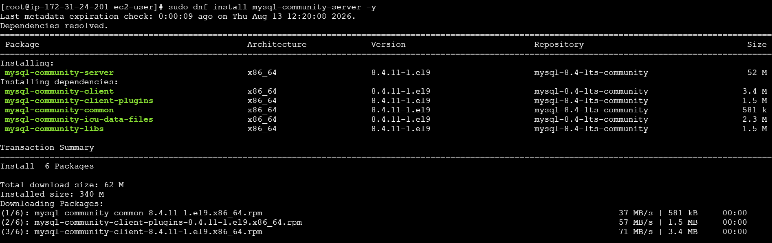
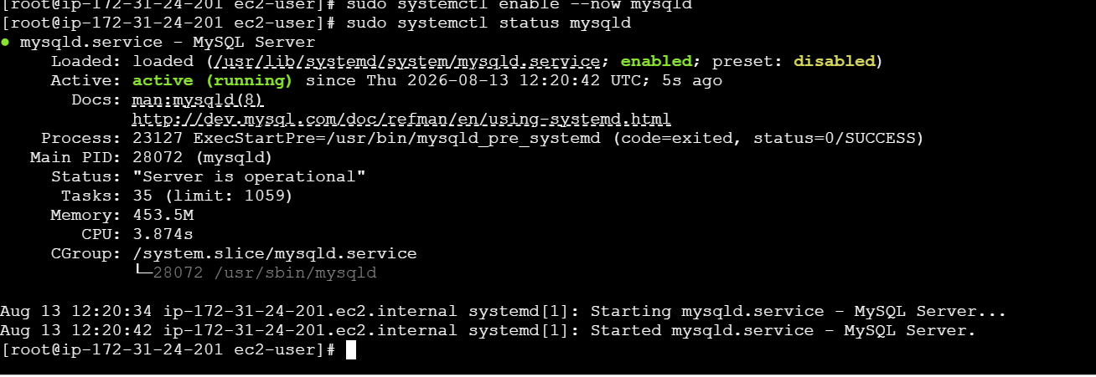
- Configure the MySQL Root Password
- You will see default MySQL root password
- grep 'temporary' /var/log/mysqld.log
- Login to mysql using the default password
- mysql -u root -p
- Now replace the default password with a new and strong password
- ALTER USER 'root'@'localhost' IDENTIFIED BY 'Admin@123';
- flush privileges;
- Test Using new password: mysql -u root -p

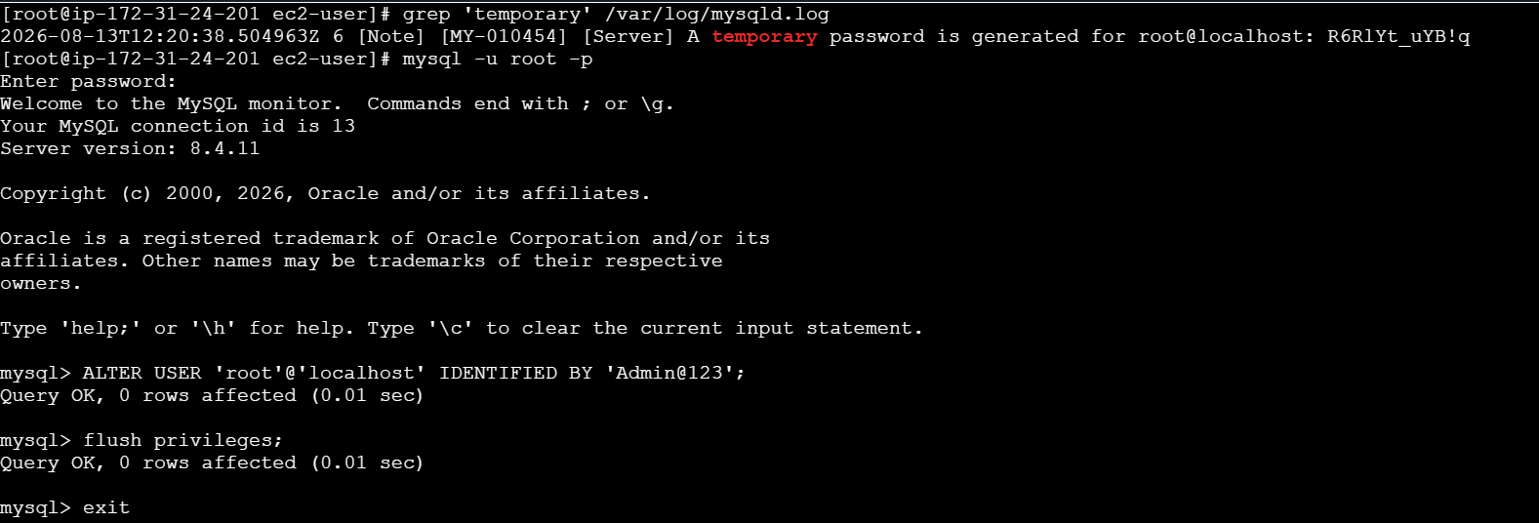

Create a new sonar database and Create a local and a remote user
- CREATE DATABASE sonar CHARACTER SET utf8 COLLATE utf8_general_ci;
- CREATE USER sonar@localhost IDENTIFIED BY 'Sonar@123';
- CREATE USER sonar@'%' IDENTIFIED BY 'Sonar@123';
- show databases;
- SELECT User FROM mysql.user;
- FLUSH PRIVILEGES;
- QUIT
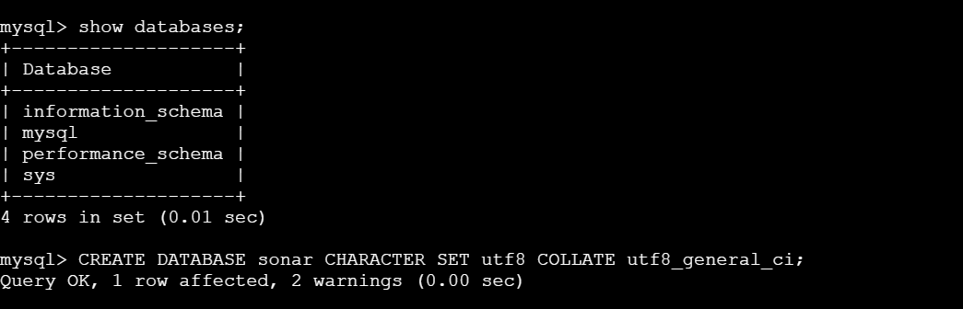
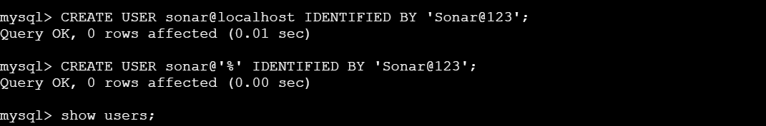
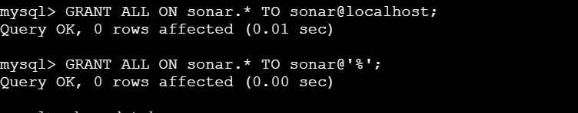
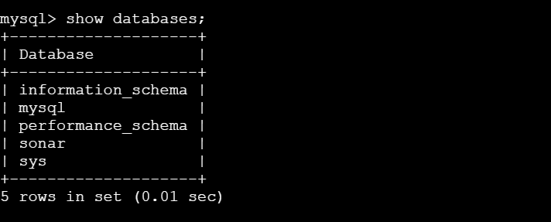
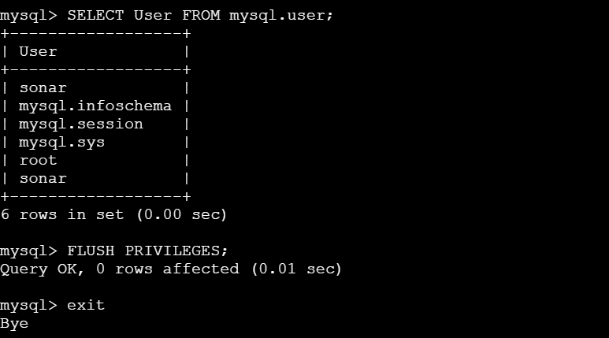
Download and unzip the SonarQube distribution ZIP directly (no Docker container) into /opt.
- cd /opt
sudo wget https://binaries.sonarsource.com/Distribution/sonarqube/sonarqube-7.8.zip
sudo unzip sonarqube- sonarqube-7.8
sudo mv sonarqube- sonarqube-7.8 sonarqube
sudo chown -R ec2-user: ec2-user /opt/sonarqube
- cd /opt/sonarqube/bin/linux-x86-64
./sonar.sh start
./sonar.sh status
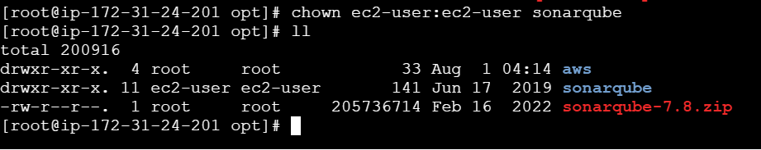
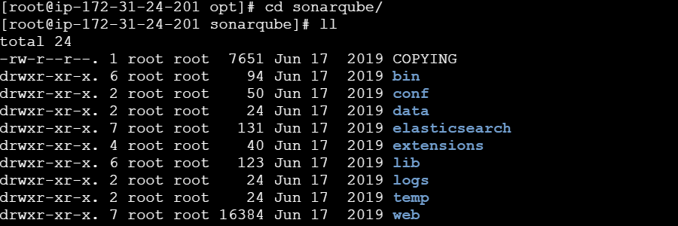
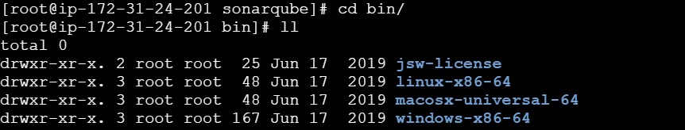
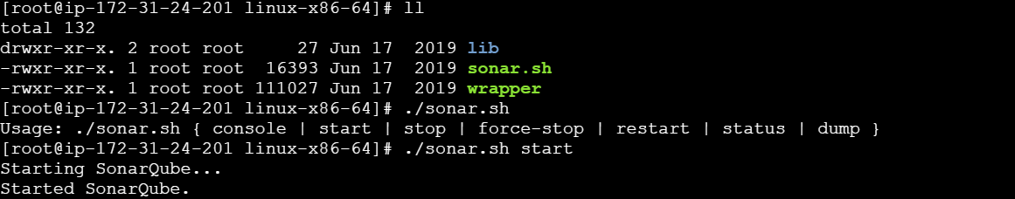

Step 2: Verify SonarQube Is Reachable and Create a Token
Parameter | Value
URL | http://<sonarqube-server-ip>:9000
Default login | admin / admin (change on first login)
Token location | My Account -> Security -> Generate Tokens
Token name | jenkins-integration-token
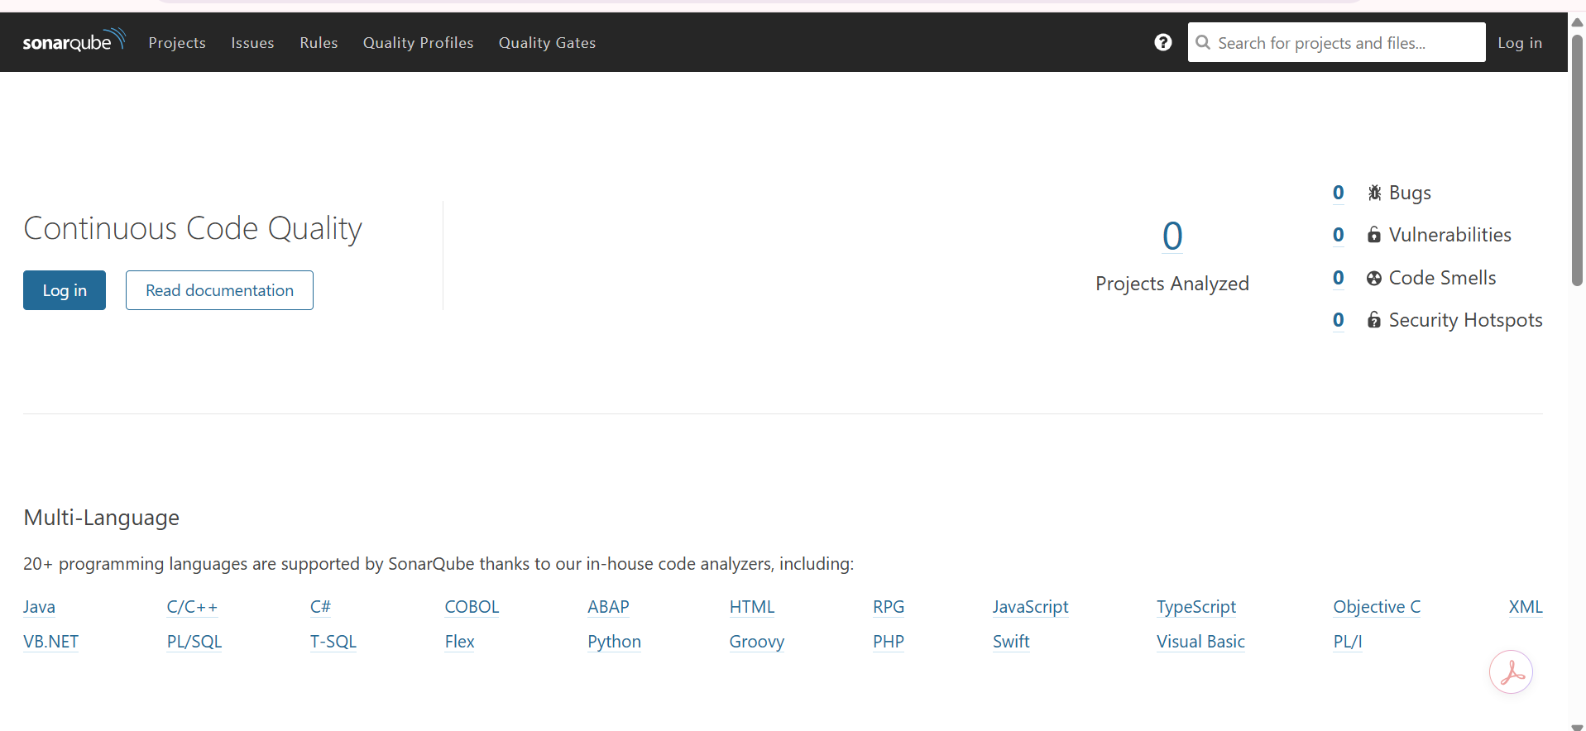
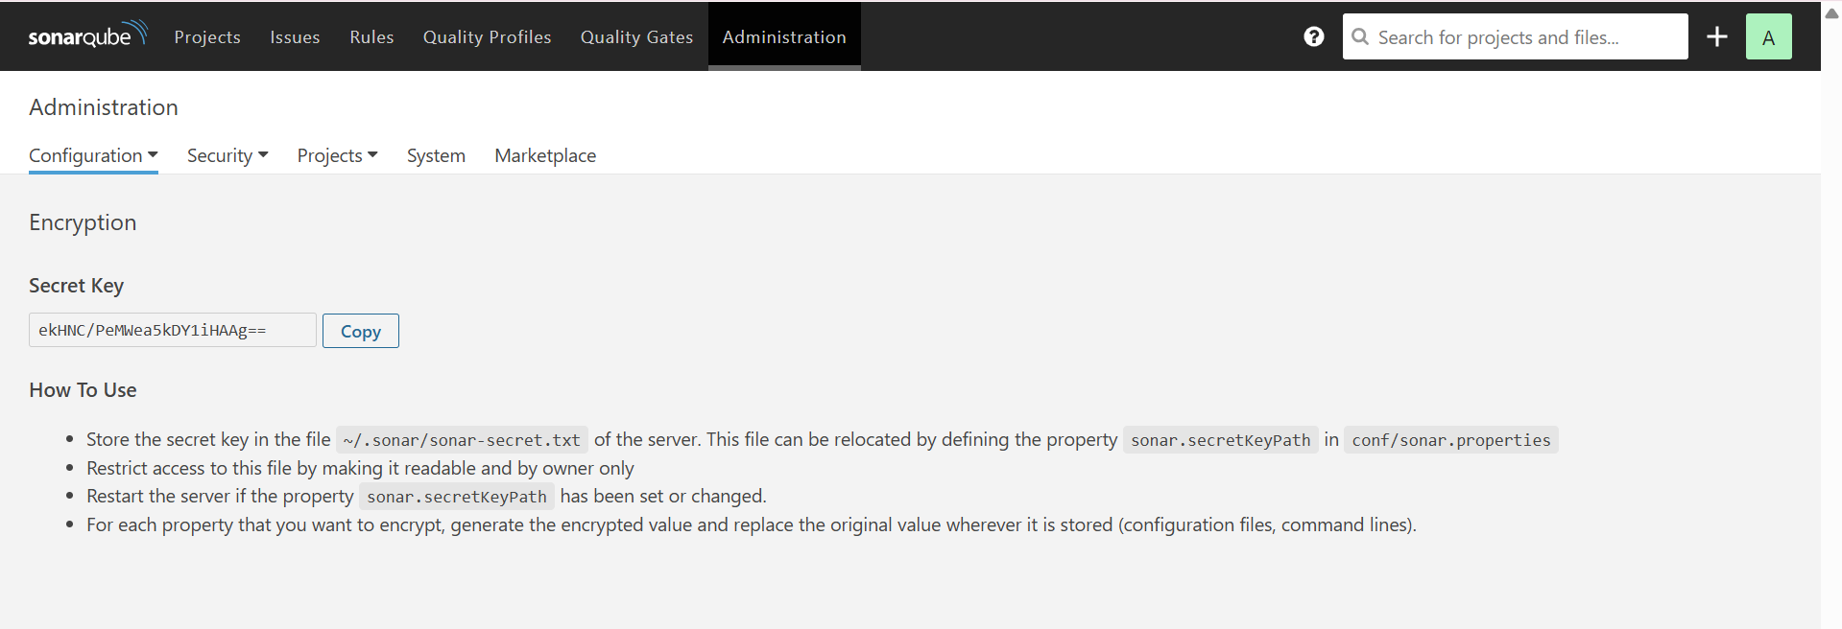

Step 3: Configure the SonarQube Server Inside Jenkins
Parameter | Value
Location | Manage Jenkins -> System -> SonarQube servers
Name | sonar-server
Server URL | http://<sonarqube-server-ip>:9000
Server authentication token | Credential built from the token generated in Step 2
Also register the scanner tool under Manage Jenkins -> Tools -> SonarQube Scanner installations, name it sonar-scanner, and let Jenkins install it automatically.
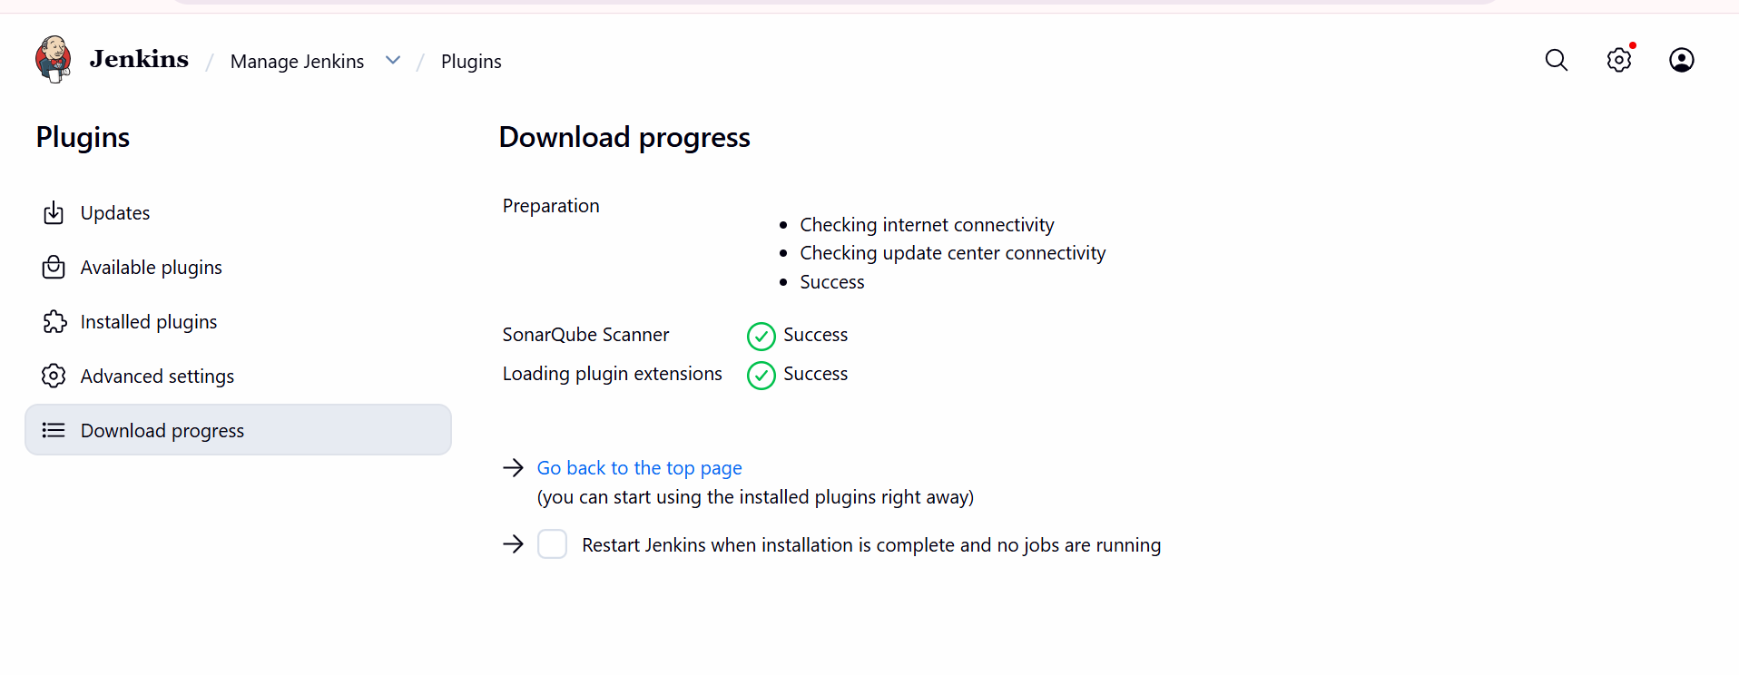
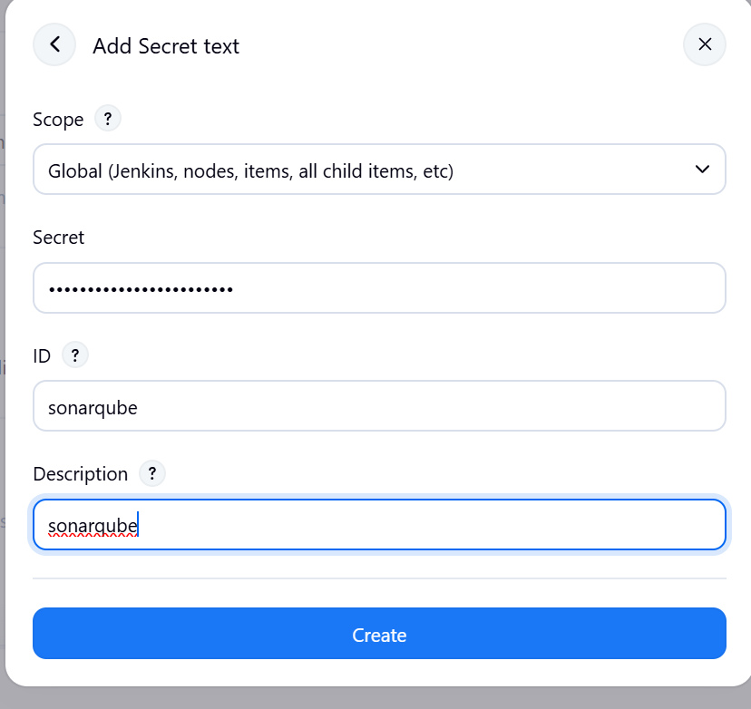
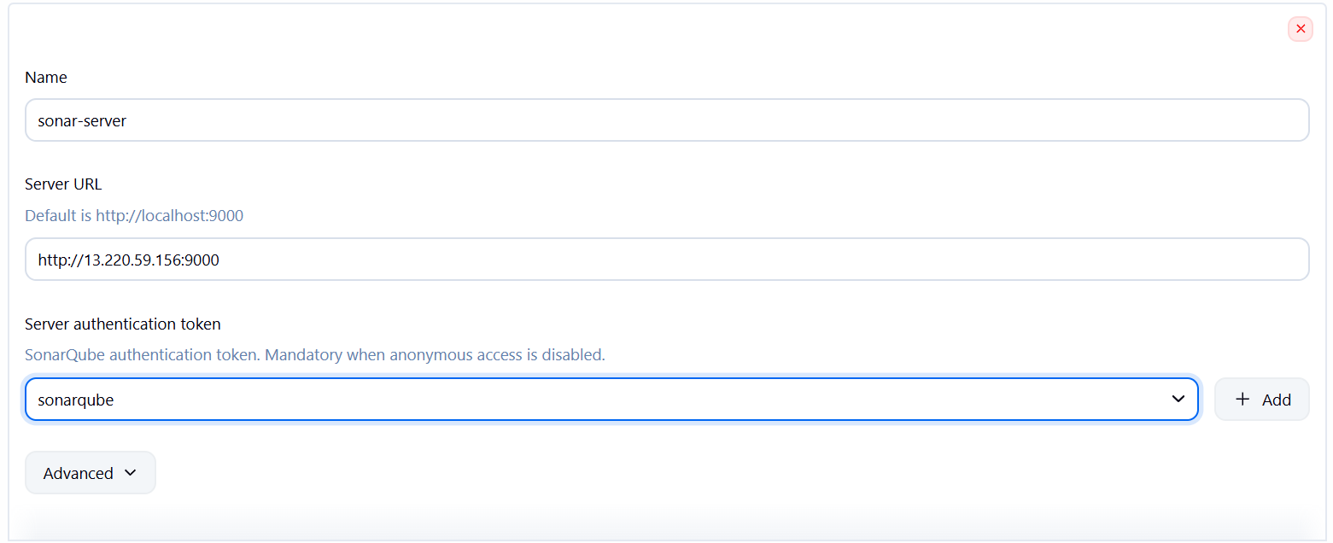
Login to Jenkins server and install sonarqube scanner.
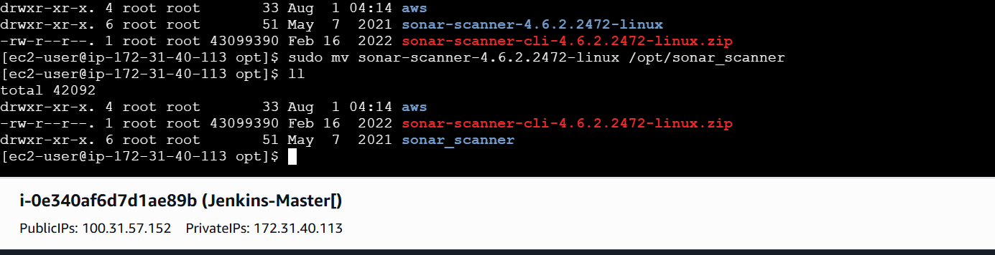
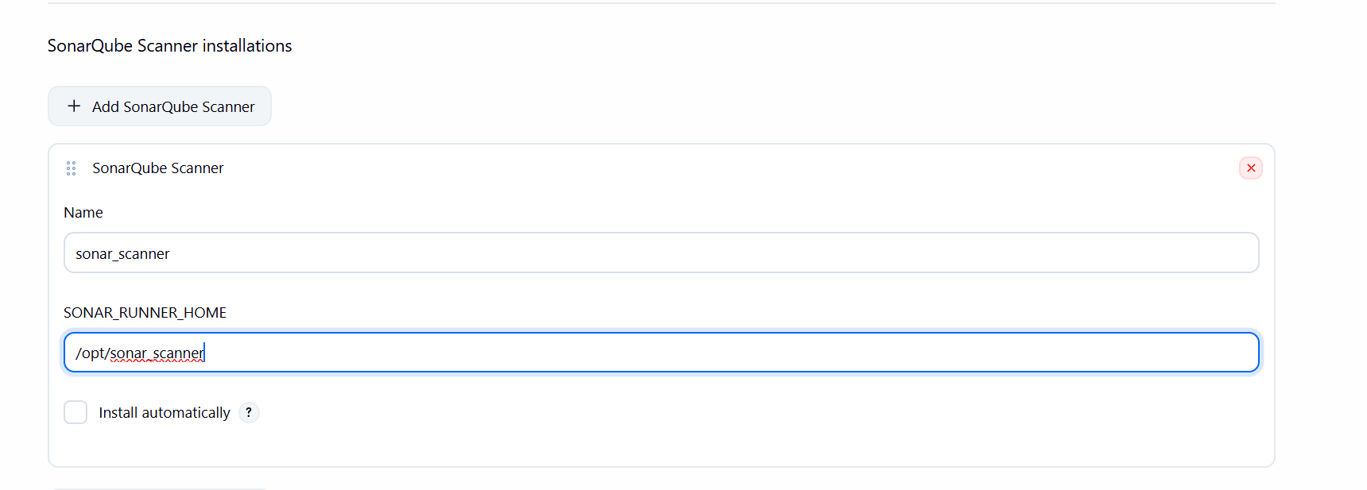
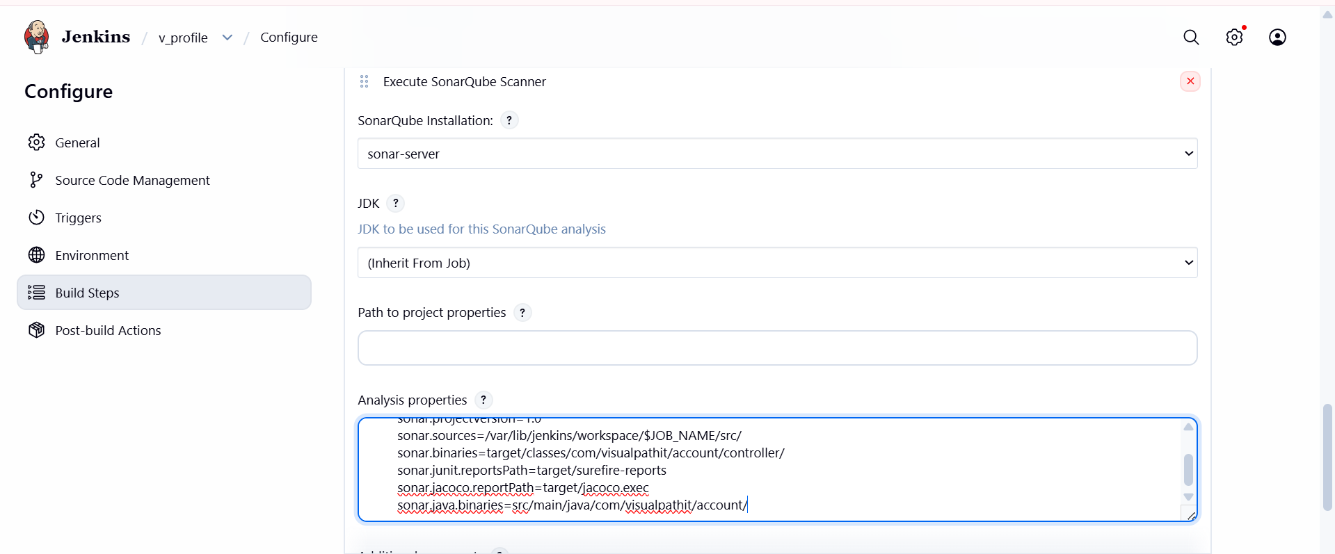
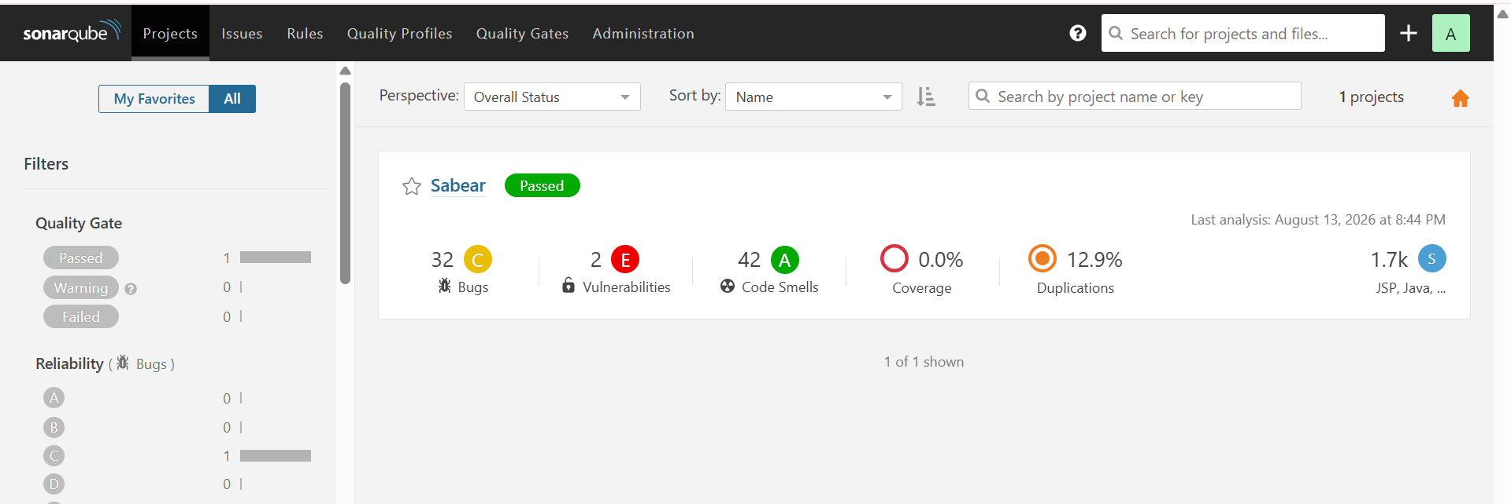

Step 4: Configure the Slack Integration
Parameter | Value
Slack side | Create a Slack app -> enable Incoming bot token -> invite the bot to the target channel
Jenkins credential | Add the Slack bot token as a Secret text credential, ID slack-token
Location | Manage Jenkins -> System -> Slack
Workspace | khadeergroup.slack.com
Credential | slack-token
Default channel | #jenkins_notification
Click Test Connection and confirm Jenkins reports success before continuing.
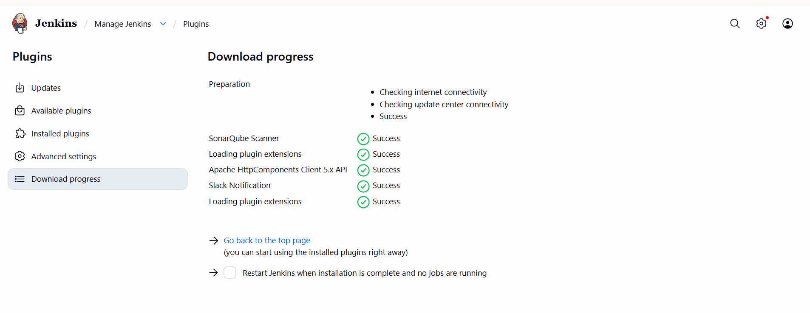

Click Plugin it Open plugin int we have int we have YAML file
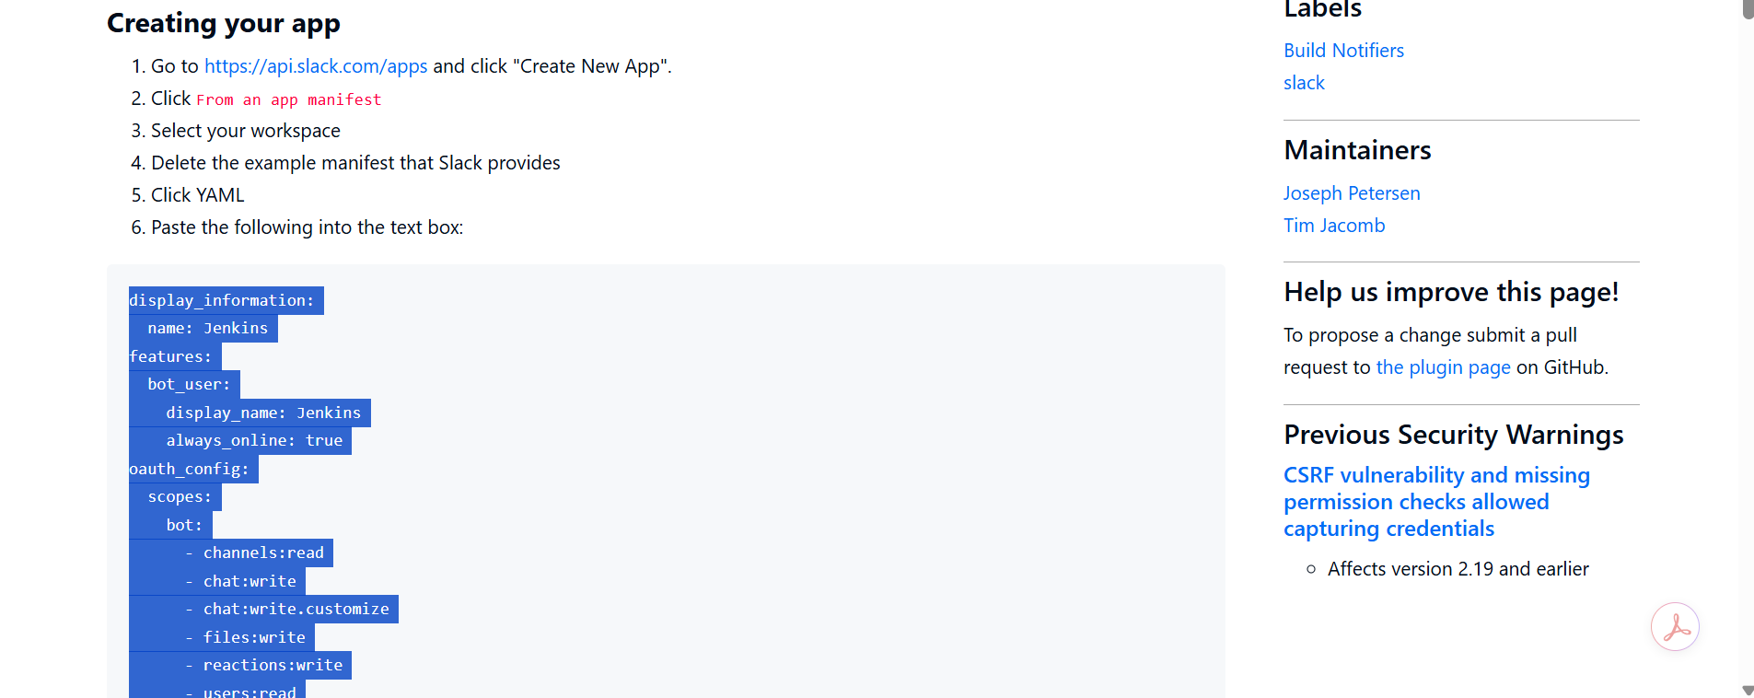
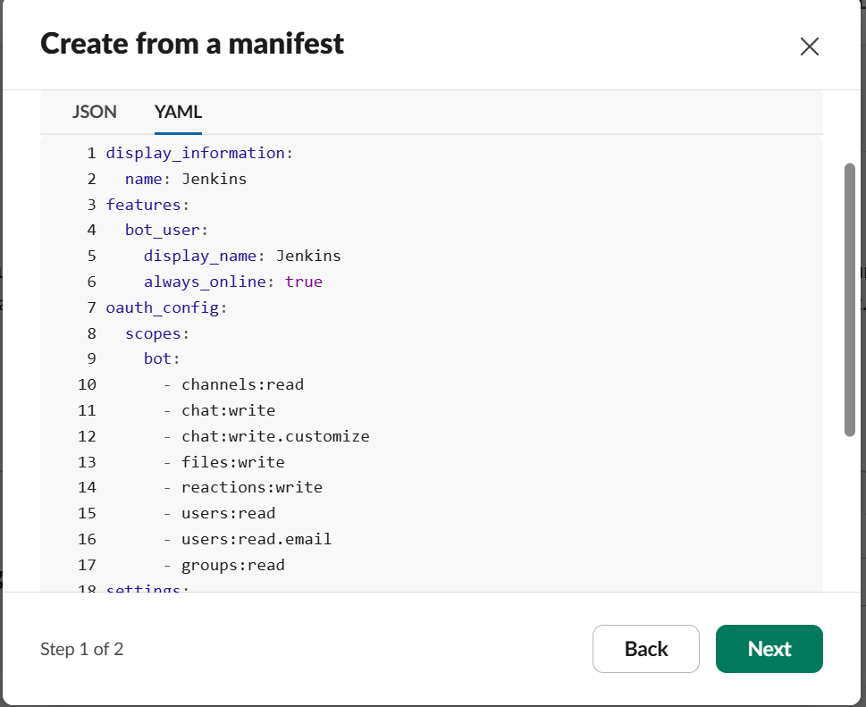
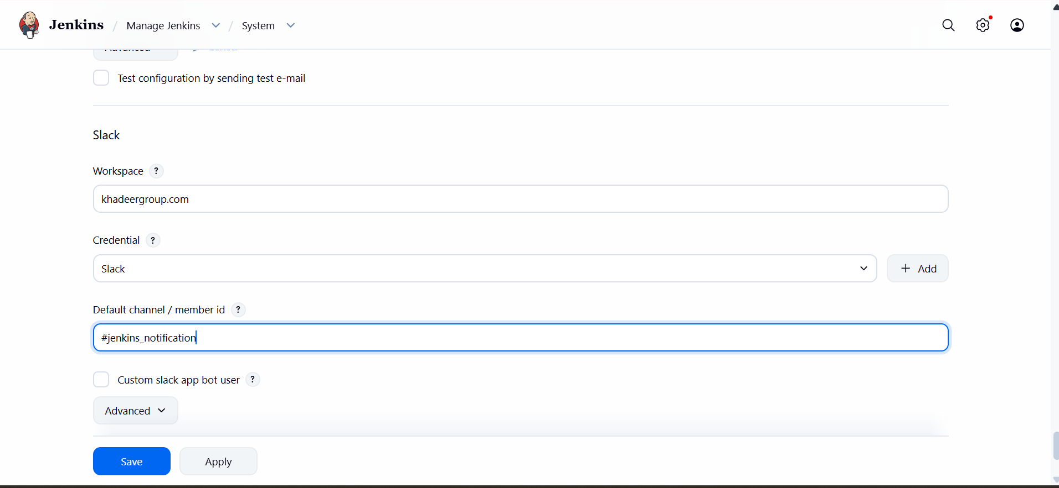
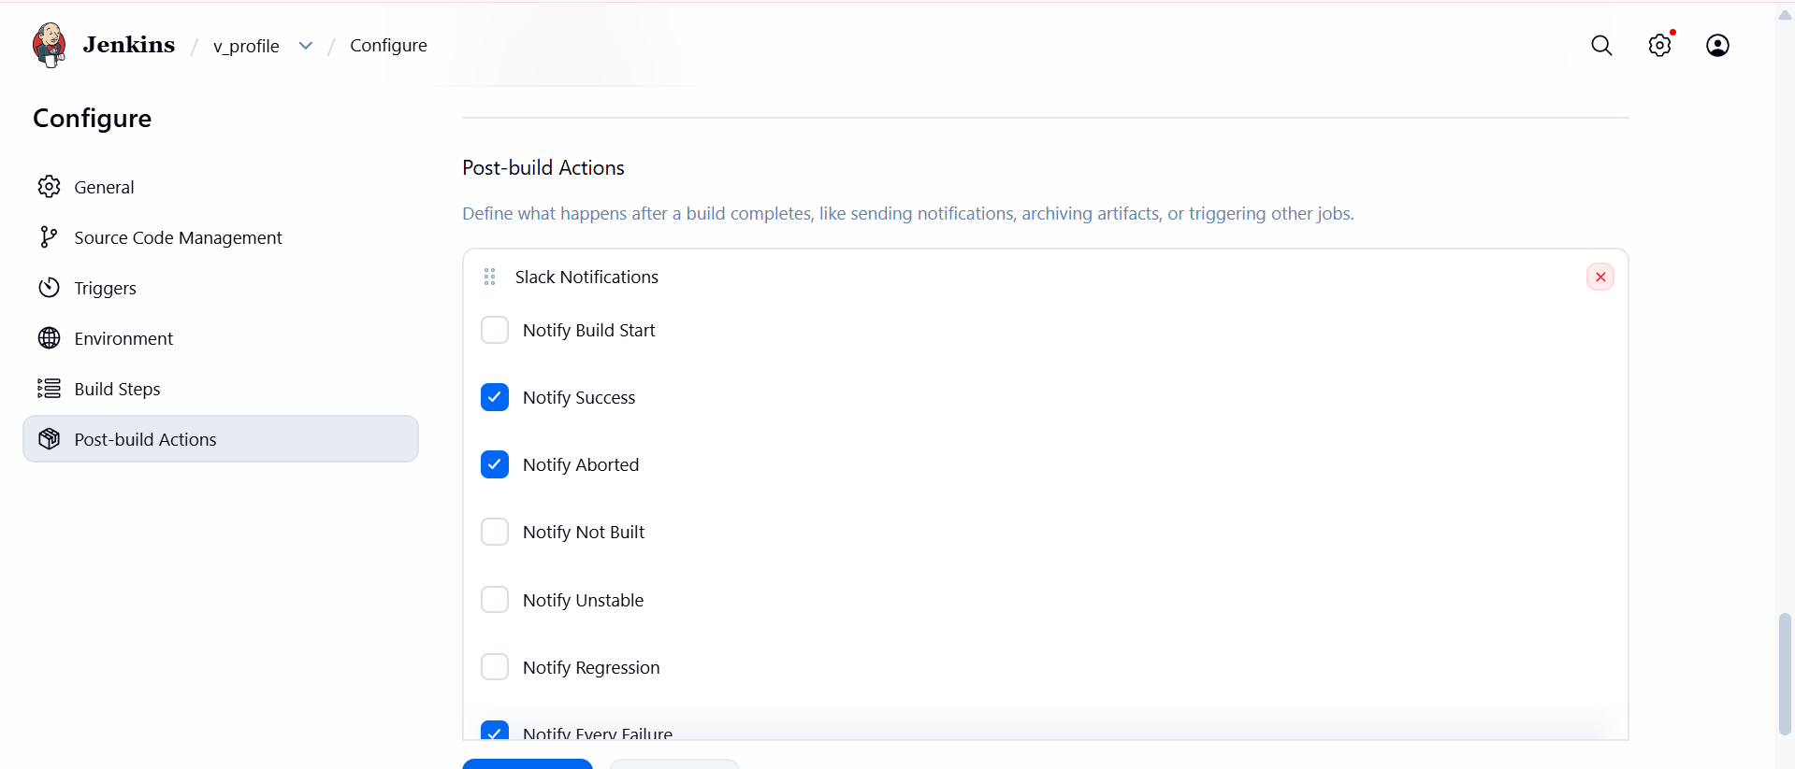

Step 5: Run the Job and Review Results
Click Build Now, then open Console Output to watch all three stages execute in order, and confirm the SonarQube project dashboard and the Slack channel both update.
📷 Screenshot Evidence: capture the console view for this step and insert it here.
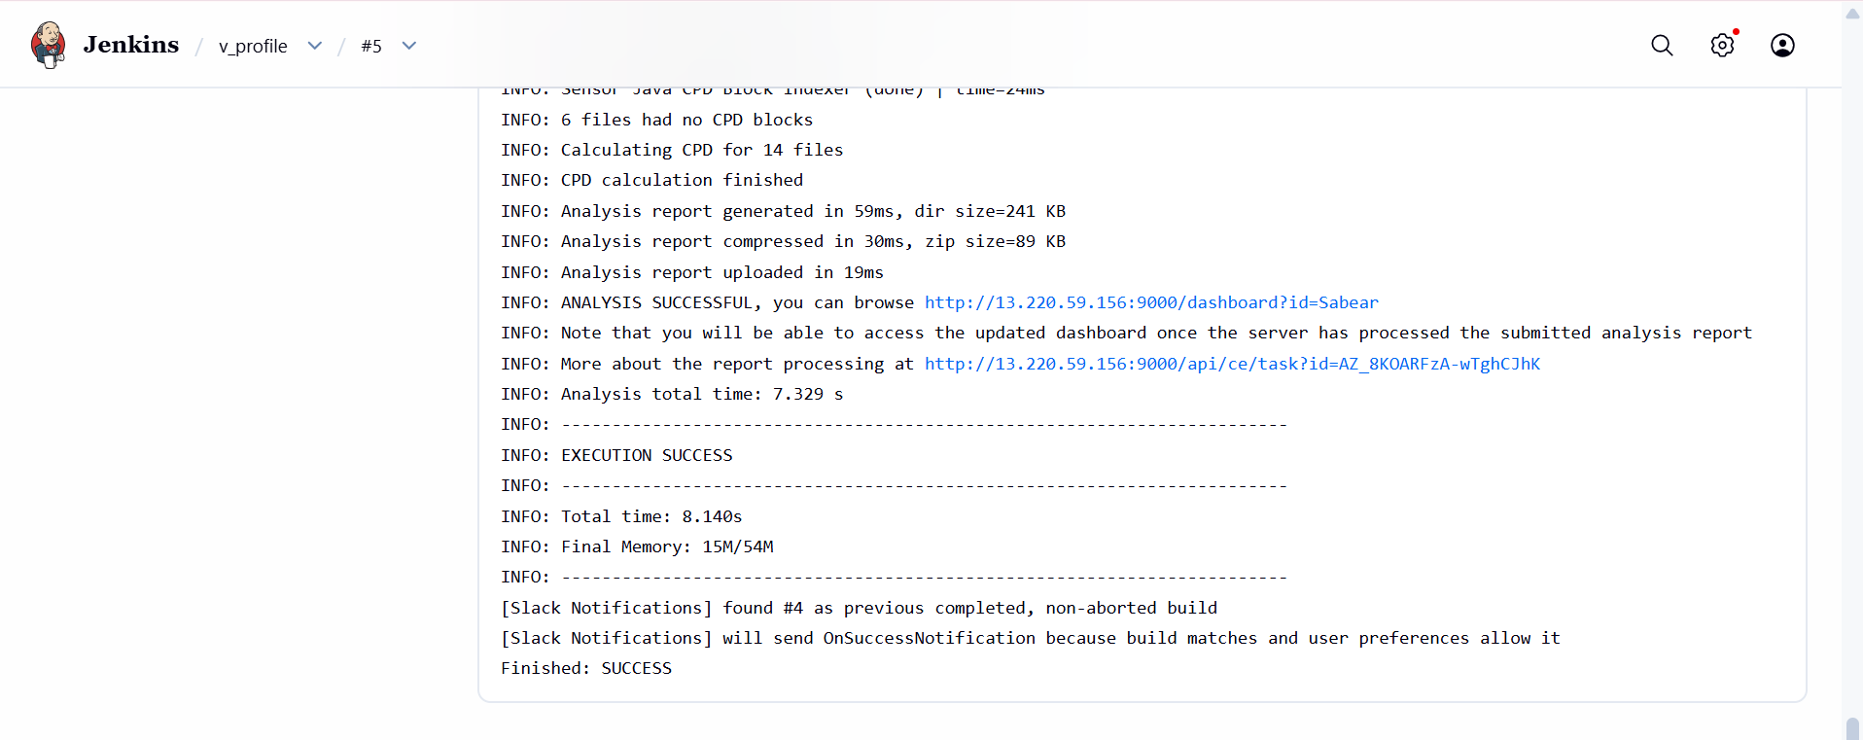
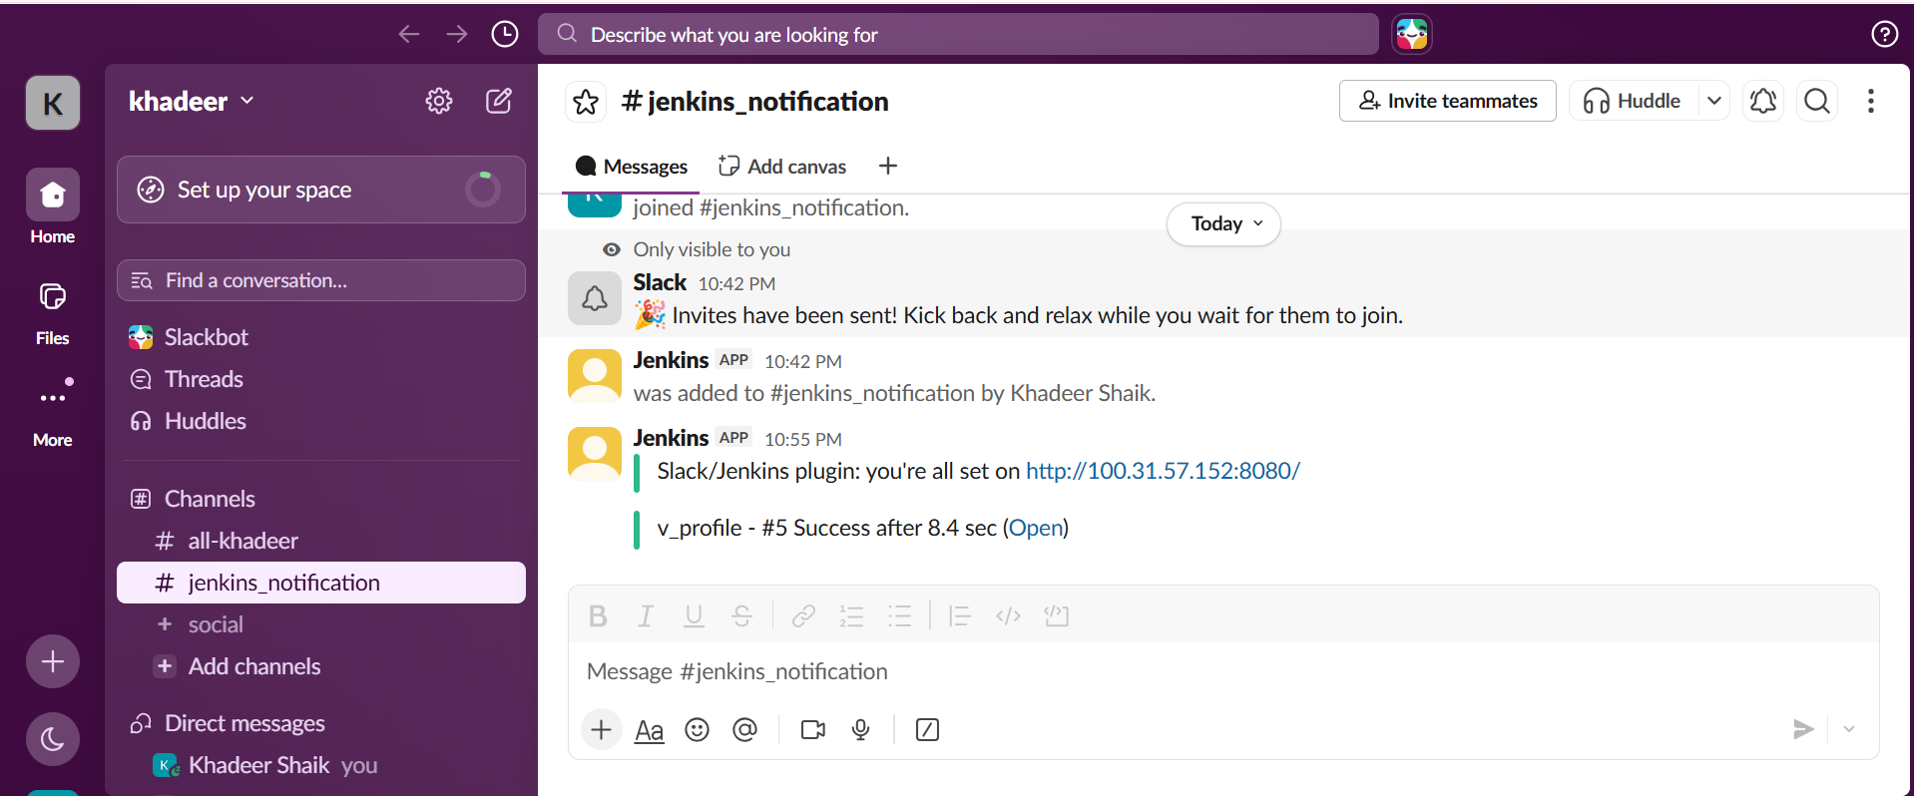

- Console Output shows the Git Clone stage checking out VProfile-1 into the workspace with no authentication errors.
- The SonarQube dashboard shows a new/updated project named VProfile-1 with a completed analysis and a Quality Gate status (Passed or Failed).
- The configured Slack channel receives a message with the build number, job name, and result immediately after the pipeline finishes.
- The Stage View in Jenkins shows all three stages (Git Clone, Sonarqube Integration, Slack Integration) completed in green.

Task 2: Pipeline Job for hiring-app (Git Clone, Dockerized SonarQube, Slack Alerts)

Step 1: Run SonarQube as a Docker Container
Pull and start the official SonarQube image, publishing the web port and using a named volume so data survives container restarts.
- Yum install docker
- Systemctl start docker
- Docker pull sonarqube
- docker run -itd -p 9001:9000 sonarqube
change the properties file for this specific port
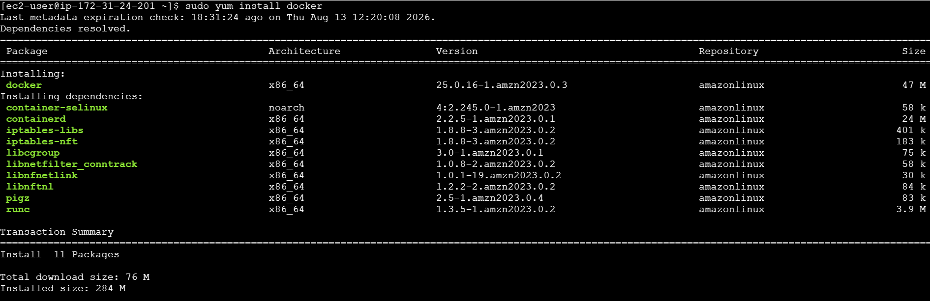
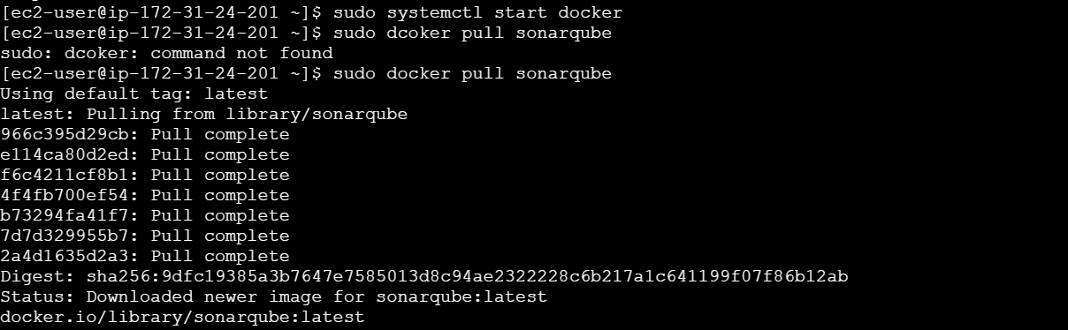
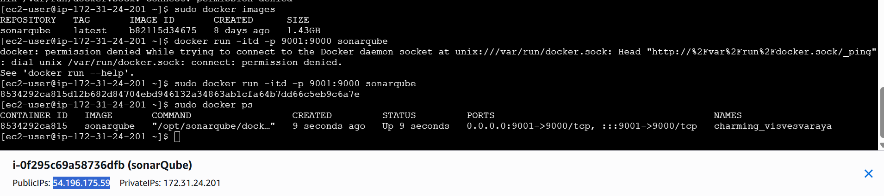

Step 2: Verify the Container and Generate a Token
Parameter | Value
URL | http://<docker-host-ip>:9000
Default login | admin / admin (change on first login)
Token location | My Account -> Security -> Generate Tokens
Token name | jenkins-hiring-app-token
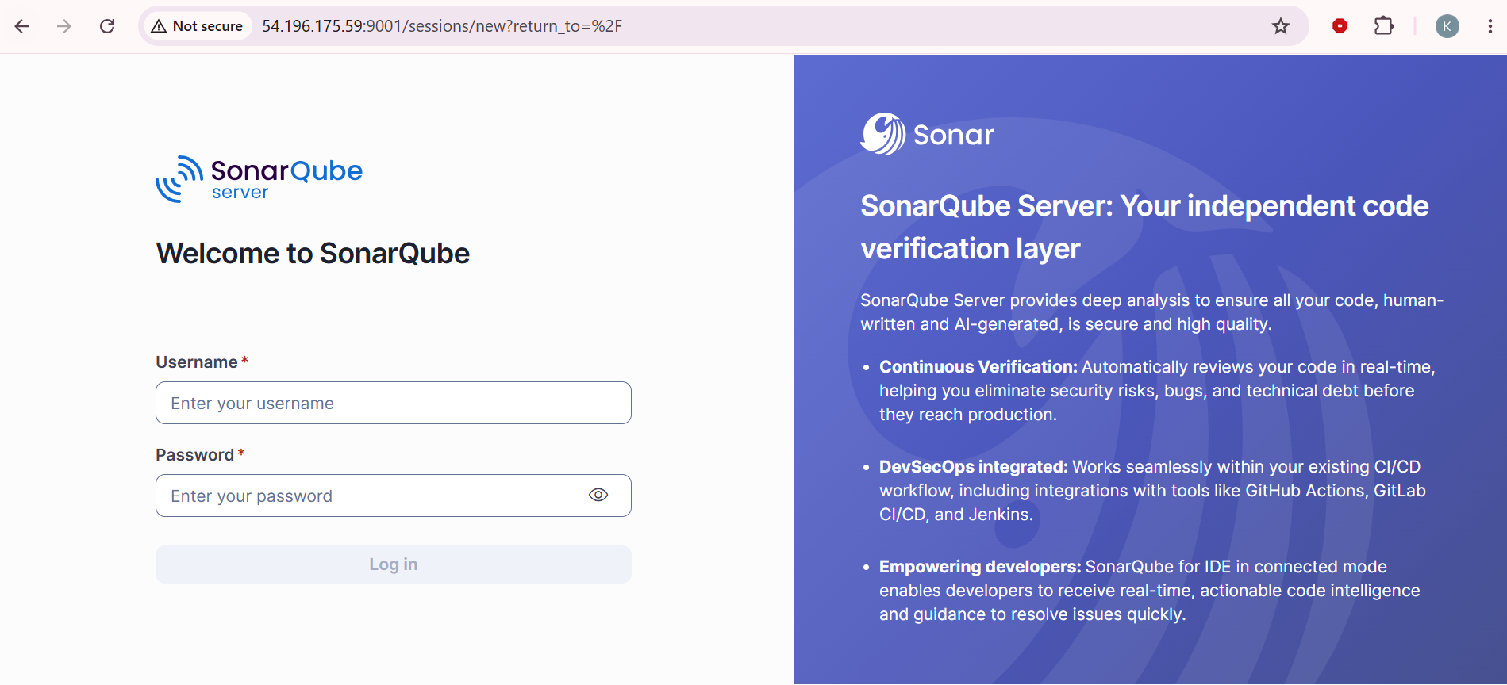
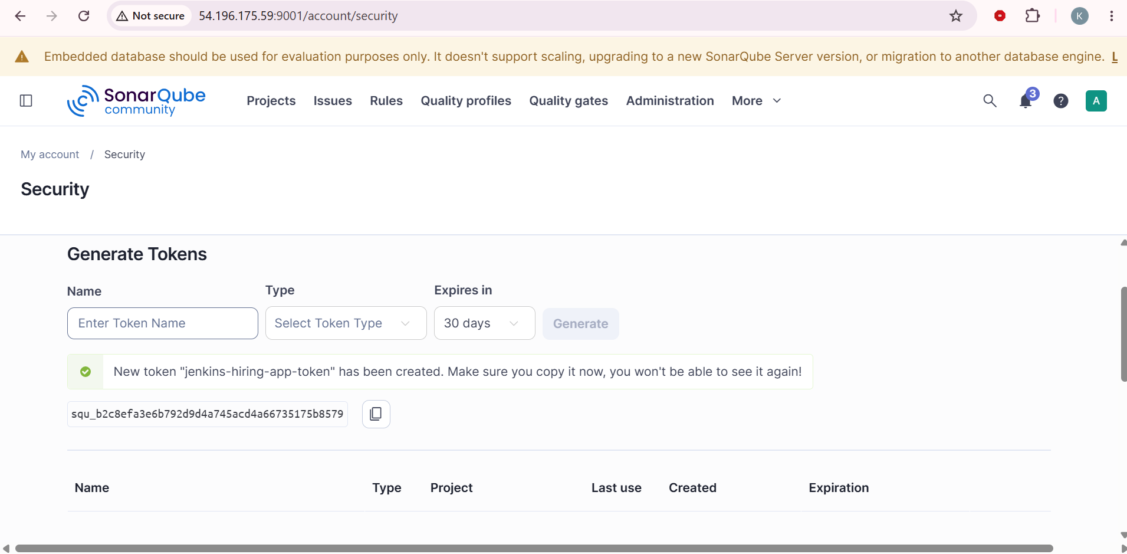

Step 3: Register the Dockerized Server Inside Jenkins
Parameter | Value
Location | Manage Jenkins -> System -> SonarQube servers
Name | sonar-server-docker
Server URL | http://<docker-host-ip>:9000
Server authentication token | Credential built from the token generated in Step 2
This is added as a second entry alongside sonar-server from Task 1; Jenkins can hold multiple SonarQube server definitions and each pipeline picks the one it needs by name.
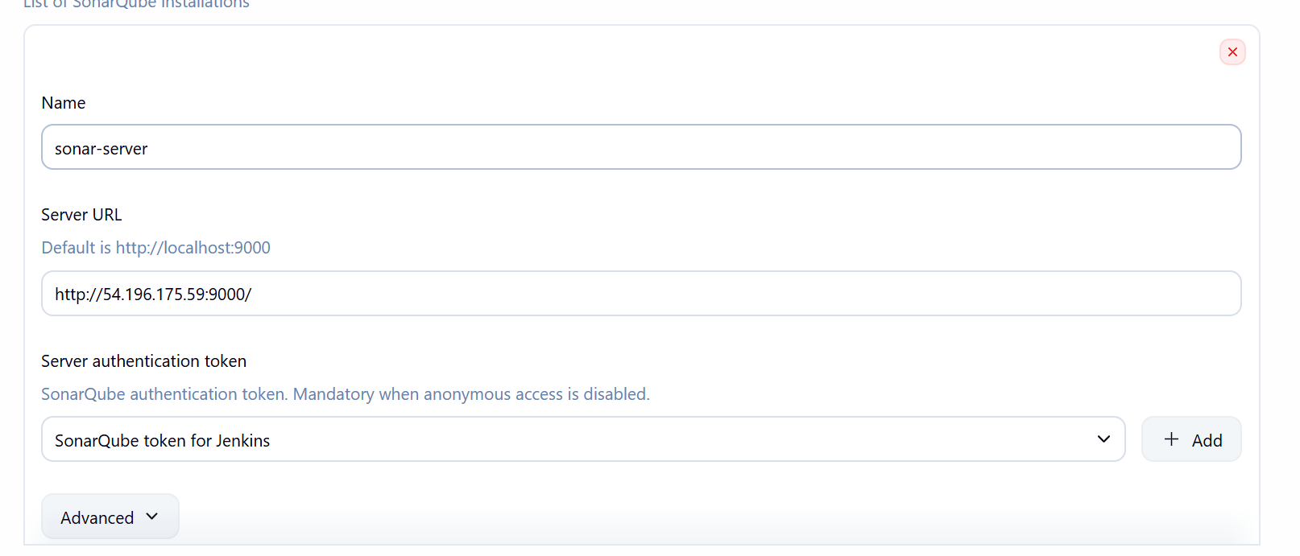

Step 4: Confirm the Shared Slack Configuration
Open Manage Jenkins -> System -> Slack and confirm the workspace and slack-token credential from Task 1 are still present, since Task 2 reuses the Slack integration rather than creating it again.
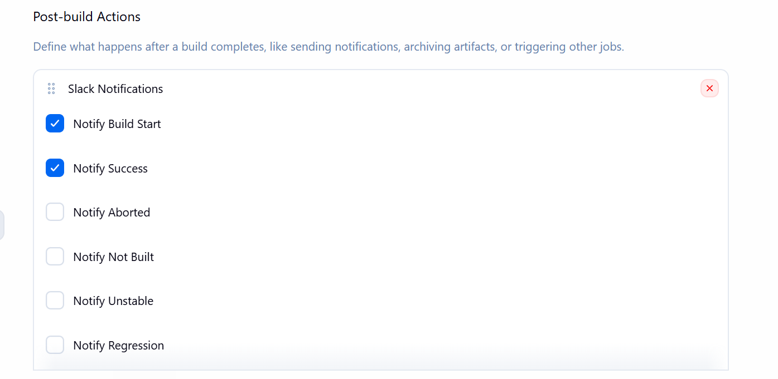

Step 5: Create the Pipeline Job
Parameter | Value
Location | New Item -> free style job
Item name | hiring-app-sonar-slack

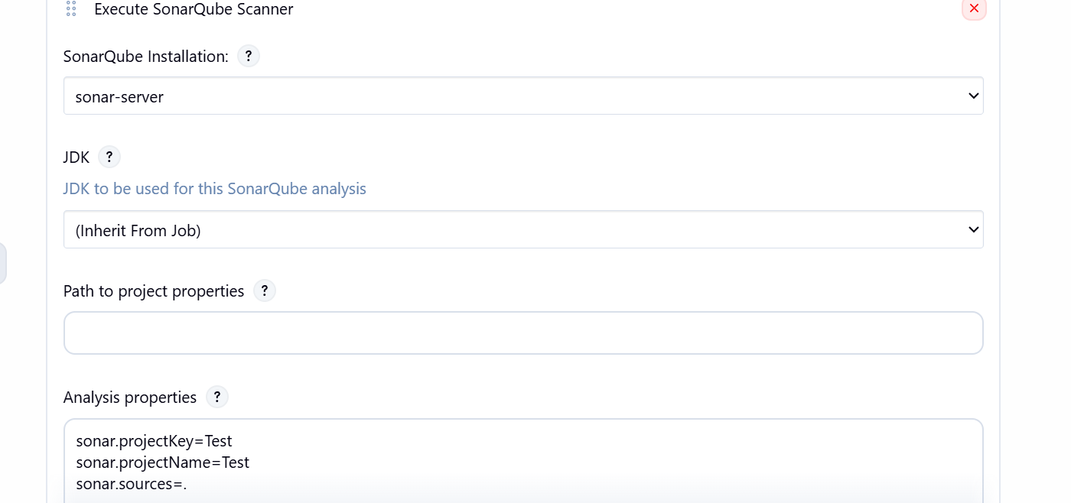

Step 6: Run the Job and Review Results
Click Build Now, then open Console Output to confirm all three stages run in order, and check both the Dockerized SonarQube dashboard and the Slack channel for the new hiring-app project and its build alert.
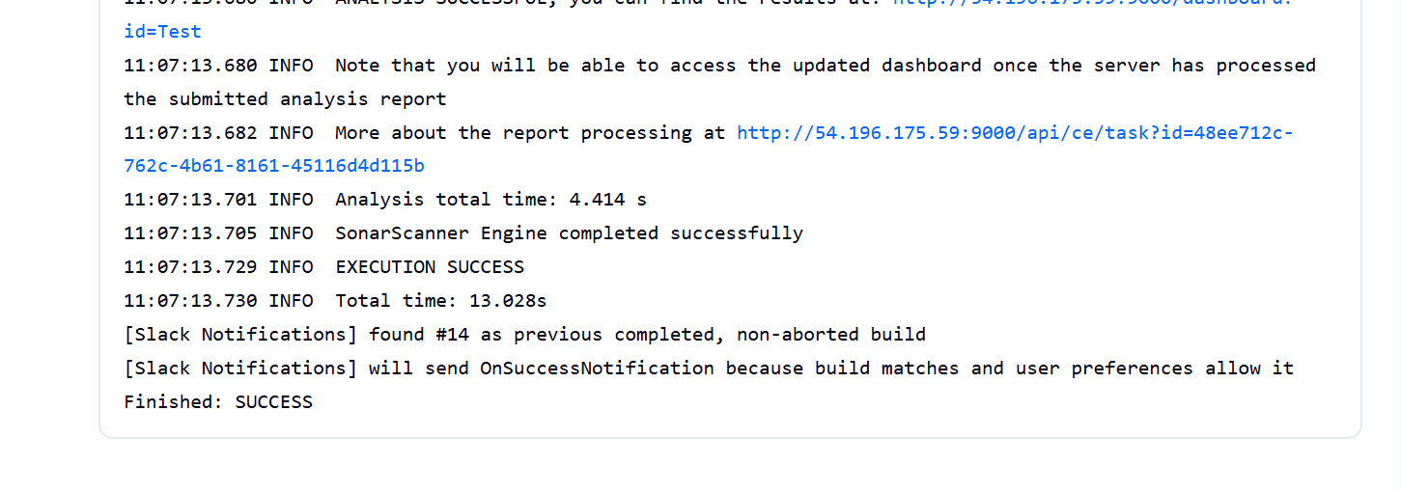
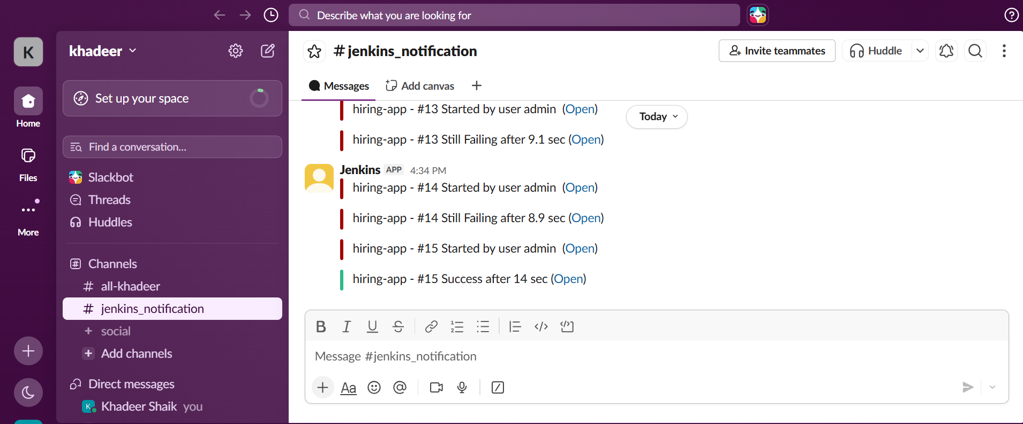
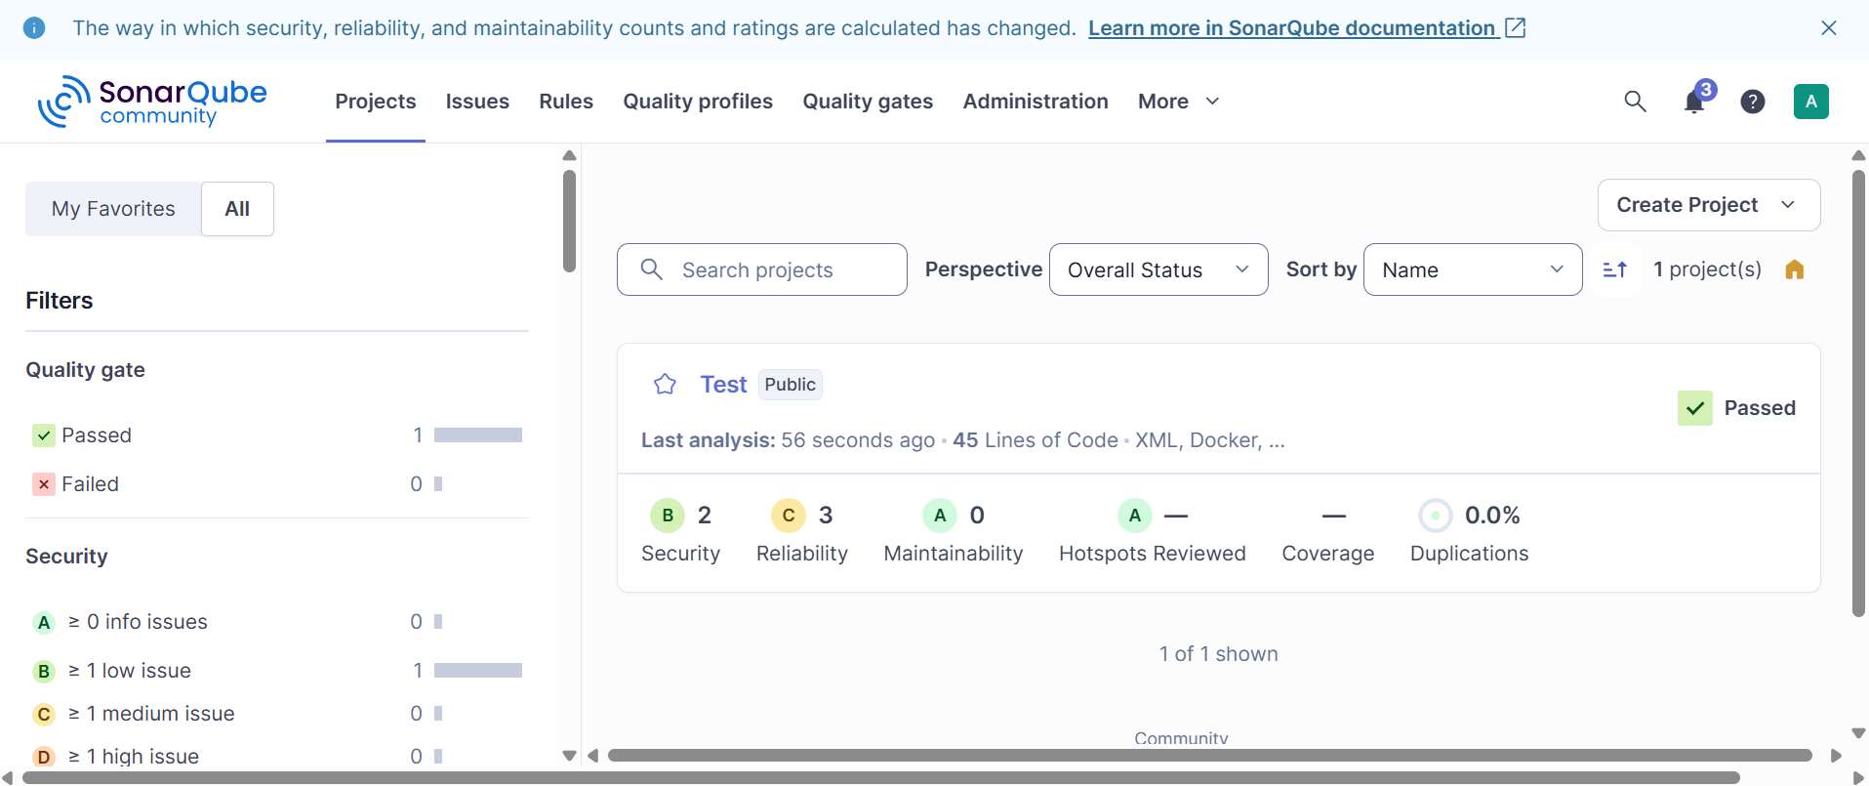
- Console Output shows the Git Clone stage checking out hiring-app into the workspace with no authentication errors.
- The SonarQube dashboard shows a new project named hiring-app with a completed analysis and Quality Gate status, alongside the existing VProfile-1 project.
- The configured Slack channel receives a message for the hiring-app build, distinct from the VProfile-1 build messages.
- The Stage View shows all three stages (Git Clone, Sonarqube Integration, Slack Integration) completed in green.

